**DAILY ONLINE ACTIVITIES SUMMARY**

|  |  |  |  |  |  |  |  |  |
| --- | --- | --- | --- | --- | --- | --- | --- | --- |
| **Date:** | **29-05-2020** | | | | | **Name:** | **Deeksha D Poojary** | |
| **Sem & Sec** | **VIII Semester & A Section** | | | | | **USN:** | **4AL16CS026** | |
| **Online Test Summary** | | | | | | | | |
| **Subject** | | **Big Data Analytics** | | | | | | |
| **Max. Marks** | | **30** | | **Score** | | | **22** | |
| **Certification Course Summary** | | | | | | | | |
| **Course** | **Introduction to Hadoop** | | | | | | | |
| **Certificate Provider** | | | **Great Learning** | | **Duration** | | | **4 Hours** |
| **Coding Challenges** | | | | | | | | |
| **Problem Statement: Write a C Program to generate first N Armstrong Numbers** | | | | | | | | |
| **Status: COMPLETED** | | | | | | | | |
| **Uploaded the report in Github** | | | | | **YES** | | | |
| **If yes Repository name** | | | | | **deekshapoojari** | | | |
| **Uploaded the report in slack** | | | | | **YES** | | | |

Online Test Details: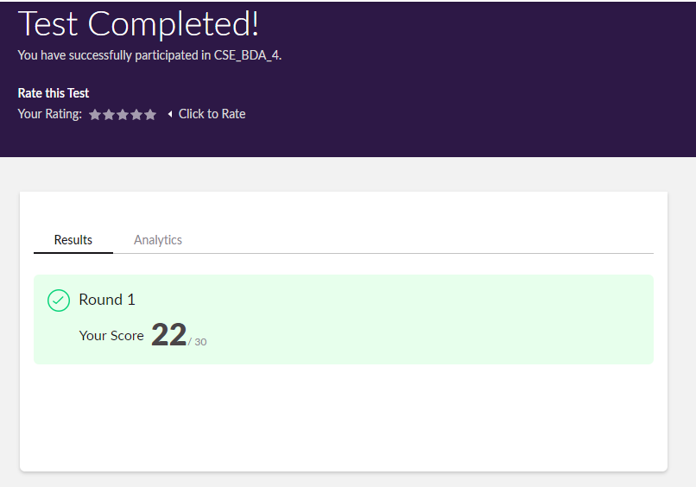

Certification Course Details:

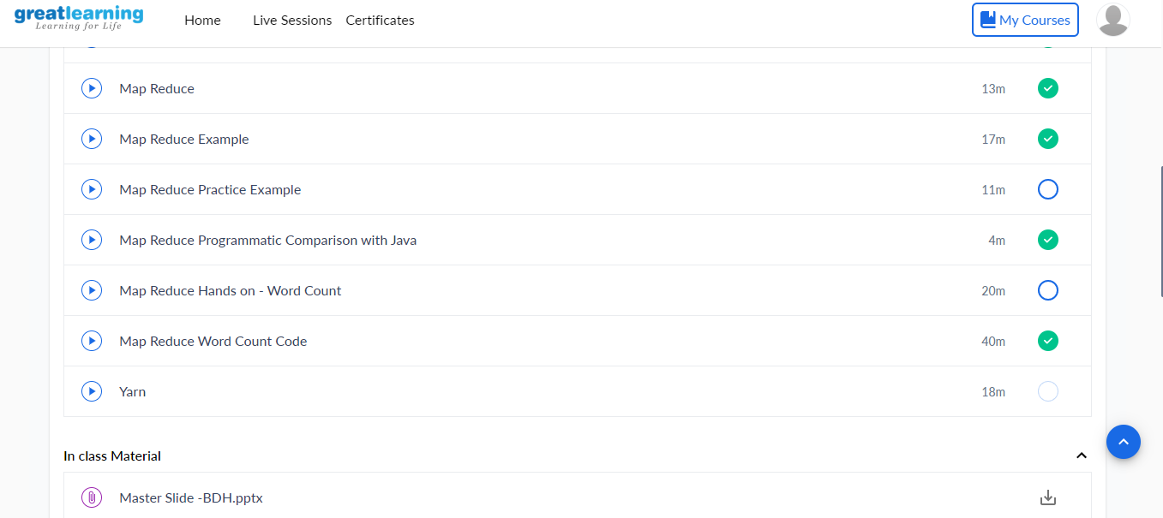

Coding Challenges Details:

|  |
| --- |
|  |
|  |
|  |
|  |
|  |
|  |
|  |
|  |
|  |
|  |
|  |
|  |
|  |
|  |
|  |
|  |
|  |
|  |
|  |
|  |
|  |
|  |
|  |
|  |
|  |
|  |
|  |
|  |
|  |
|  |
|  |
|  |
|  |
|  |
|  |
|  |
|  |
|  |
|  |
|  |
|  |
|  |
|  |
|  |
|  |
|  |
|  |
|  |
|  |
|  |
|  |
|  |
|  |
|  |

**Program1:**

|  |
| --- |
| **#include<stdio.h>** |
|  | **int main()** |
|  | **{** |
|  | **int n,r,sum=0,temp;** |
|  | **printf("enter the number=");** |
|  | **scanf("%d",&n);** |
|  | **temp=n;** |
|  | **while(n>0)** |
|  | **{** |
|  | **r=n%10;** |
|  | **sum=sum+(rrr);** |
|  | **n=n/10;** |
|  | **}** |
|  | **if(temp==sum)** |
|  | **printf("armstrong number ");** |
|  | **else** |
|  | **printf("not armstrong number");** |
|  | **return 0;** |
|  | **}** |
|  |  |